AI ASSISTED CODING
Lab Assignment-2.1
Name: Thulasi Shylasri
HTNO:2303A51876
Batch-14(LAB-2)
Date: 12-01-2026
1Q) Task 1: Statistical Summary for Survey Data
- Scenario:
You are a data analyst intern working with survey responses stored as numerical lists.
- Task:
Use Google Gemini in Colab to generate a Python function that reads a list of numbers and calculates the mean, minimum, and maximum values.
- Expected Output:
  - Correct Python function
  - Output shown in Colab
  - Screenshot of Gemini prompt and result

- Prompt:
#Write a Python function that takes a list of numbers and calculates the mean, minimum, and maximum values.
Screenshot:
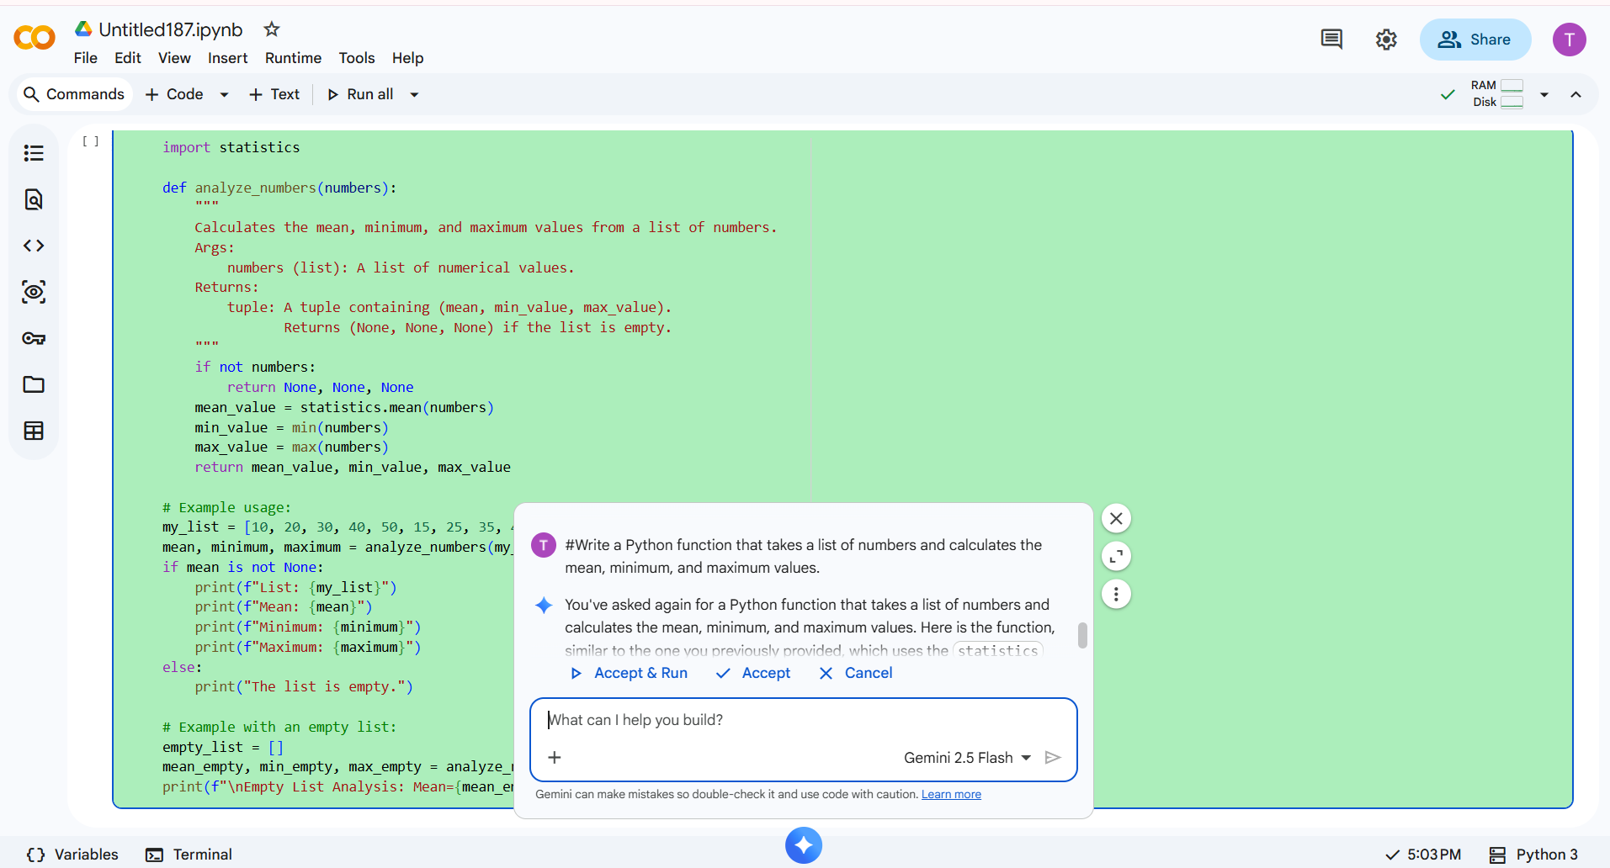
Code:
#AI Assistant Coding LAB-2(2303A51876)12-1-2026(Monday)
import statistics
def analyze_numbers(numbers):
"""
Calculates the mean, minimum, and maximum values from a list of numbers.
Args:
numbers (list): A list of numerical values.
Returns:
tuple: A tuple containing (mean, min_value, max_value).
Returns (None, None, None) if the list is empty.
"""
if not numbers:
return None, None, None
mean_value = statistics.mean(numbers)
min_value = min(numbers)
max_value = max(numbers)
return mean_value, min_value, max_value
# Example usage:
my_list = [10, 20, 30, 40, 50, 15, 25, 35, 45]
mean, minimum, maximum = analyze_numbers(my_list)
if mean is not None:
print(f"List: {my_list}")
print(f"Mean: {mean}")
print(f"Minimum: {minimum}")
print(f"Maximum: {maximum}")
else:
print("The list is empty.")
# Example with an empty list:
empty_list = []
mean_empty, min_empty, max_empty = analyze_numbers(empty_list)
print(f"\nEmpty List Analysis: Mean={mean_empty}, Min={min_empty}, Max={max_empty}")
Scenario:
Survey responses are stored as numerical values, and statistical measures are required for analysis.
Screenshot:
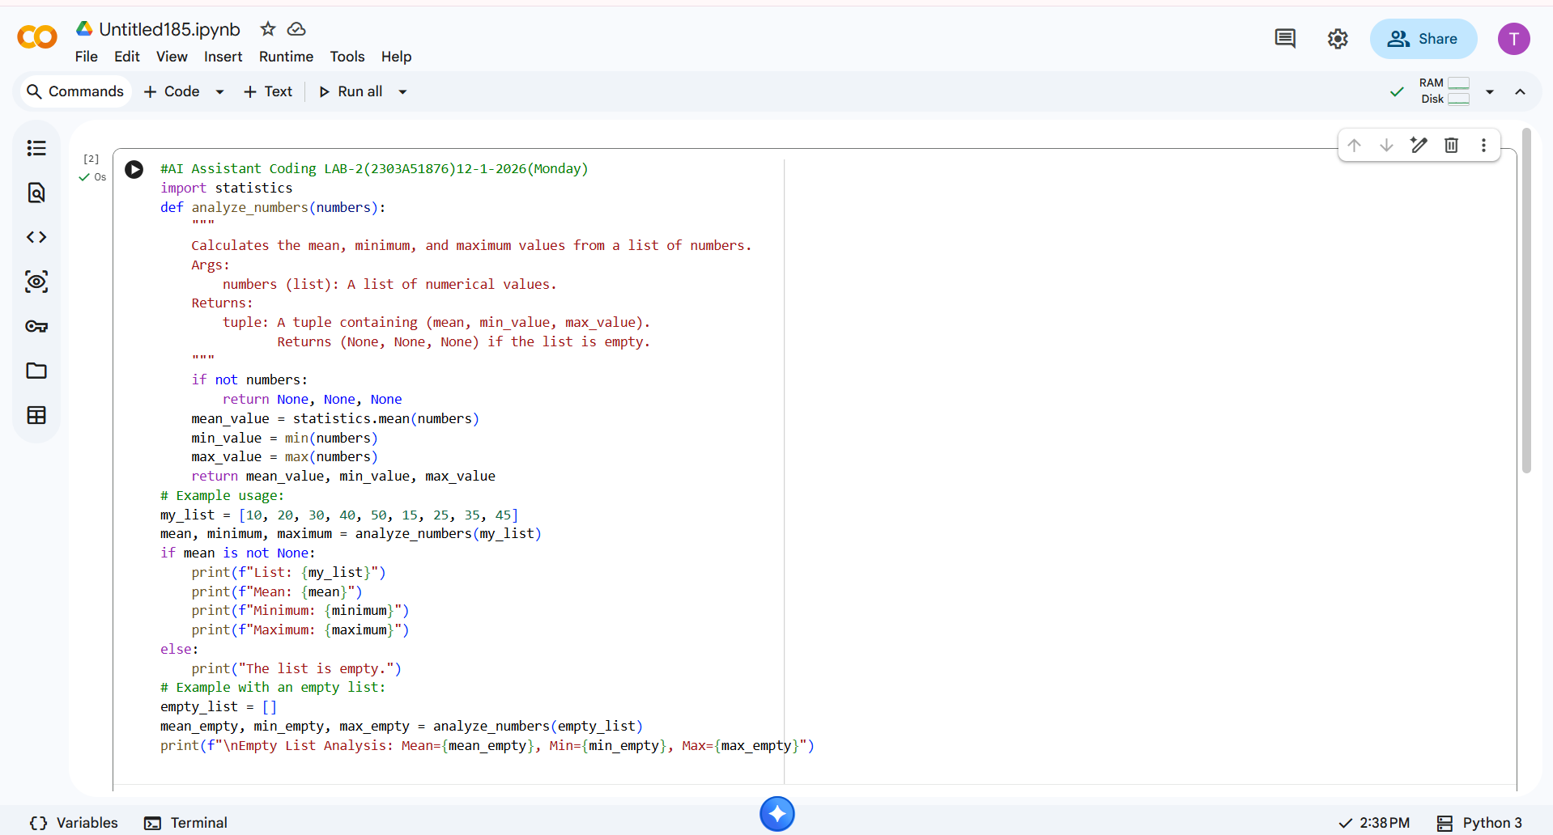
Output:
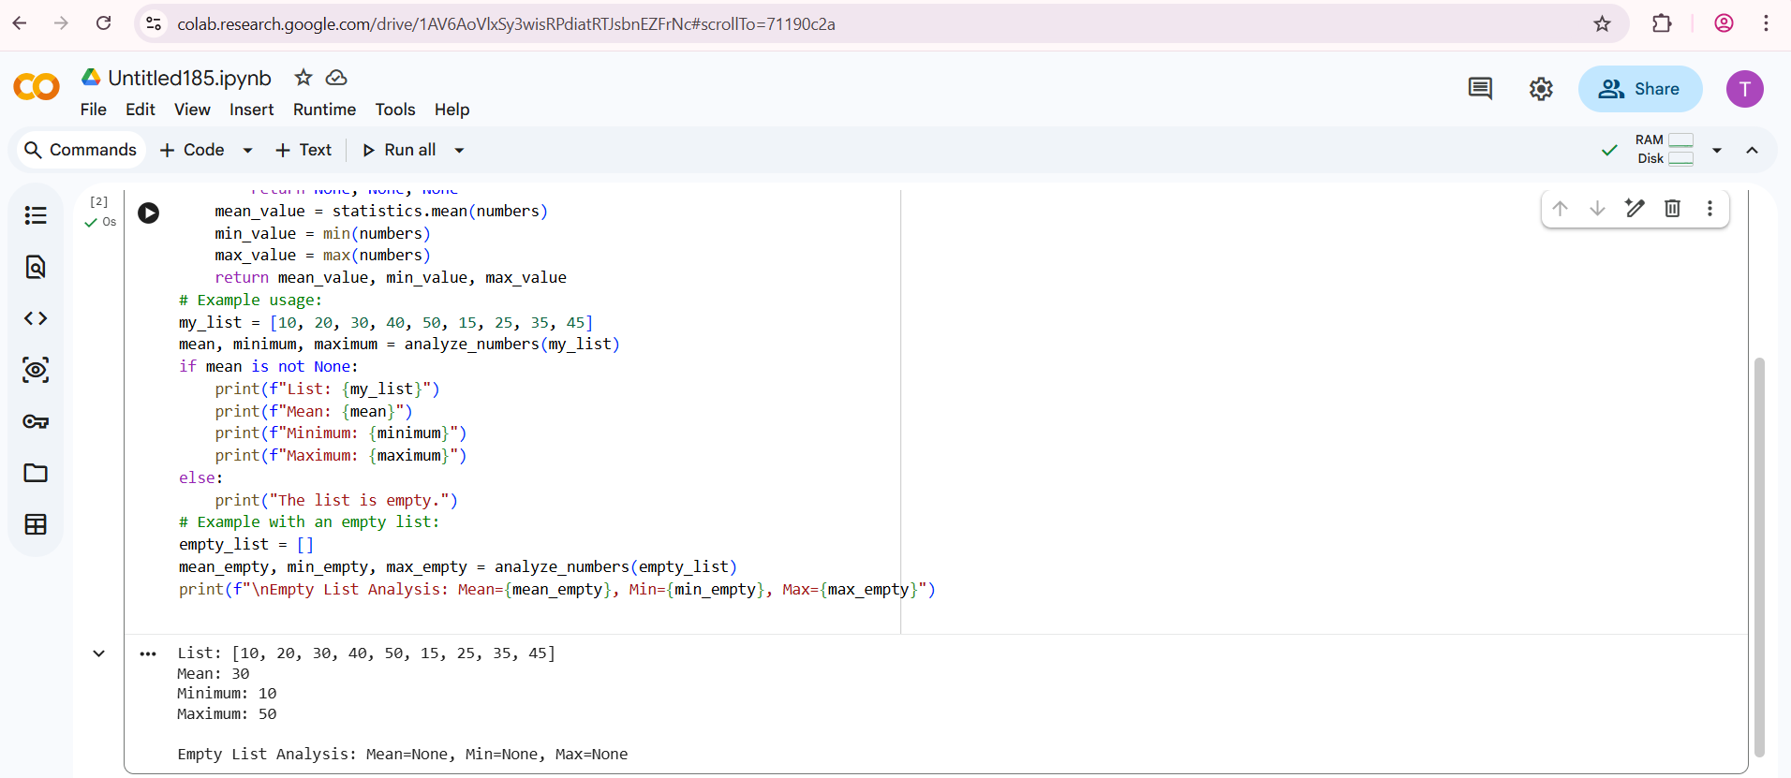

Explanation:
• The code is a Python function that takes a list of numbers and calculates the mean, minimum, and maximum values.
• The function first checks if the list is empty and returns None, None, None if it is.
• Then it calculates the mean by summing up all the numbers and dividing by the number of numbers.
• Then it calculates the minimum by finding the smallest number in the list.
• Then it calculates the maximum by finding the largest number in the list.
• Finally it returns the mean, minimum, and maximum values.
Justification:
Survey data analysis is a common real-world task in data analytics. Calculating mean, minimum, and maximum values helps summarize user responses and identify trends. Using Google Gemini in Colab demonstrates how AI can quickly generate accurate statistical functions.

Task-1
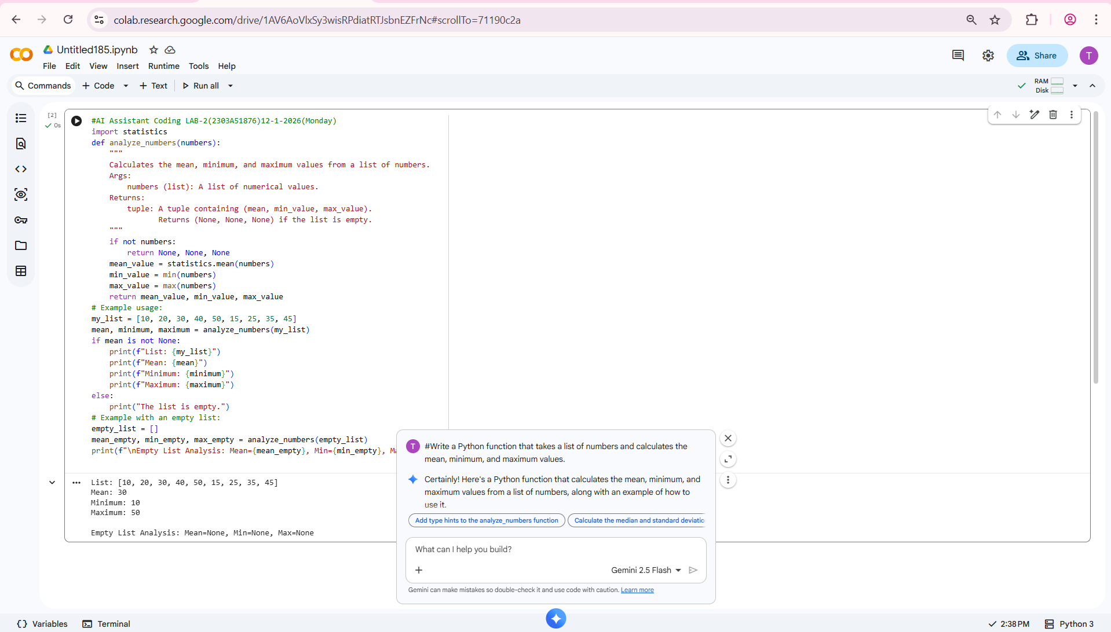

2Q) Task 2: Armstrong Number – AI Comparison
- Scenario:
You are evaluating AI tools for numeric validation logic.
- Task:
Generate an Armstrong number checker using Gemini and GitHub Copilot.
Compare their outputs, logic style, and clarity.
- Expected Output:
  - Side-by-side comparison table
  - Screenshots of prompts and generated code

Prompt for Google Gemini:
# Write a Python program to check whether a given number is an Armstrong number.
Explain the logic.
Screenshot:
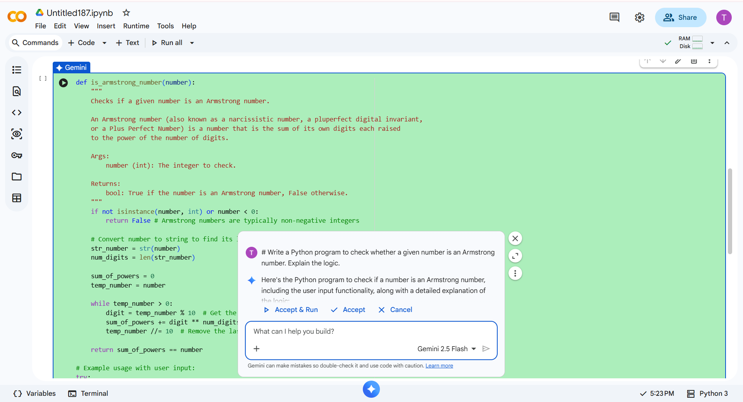
Code:
def is_armstrong(number):
"""
Checks if a given number is an Armstrong number.
An Armstrong number is a number that is equal to the sum of its own digits
each raised to the power of the number of digits.
Args:
number (int): The integer to check.
Returns:
bool: True if the number is an Armstrong number, False otherwise.
"""
if not isinstance(number, int) or number < 0:
return False # Armstrong numbers are typically positive integers

# Convert the number to a string to easily get digits and count them
num_str = str(number)
num_digits = len(num_str)
sum_of_powers = 0
temp_number = number # Use a temporary variable to extract digits
while temp_number > 0:
digit = temp_number % 10 # Get the last digit
sum_of_powers += digit ** num_digits # Add digit raised to the power of num_digits
temp_number //= 10 # Remove the last digit
return sum_of_powers == number
# --- Example Usage ---
n=int(input("Enter the number: "))
print(is_armstrong(n))

Scenario:
Armstrong number logic is used to test numeric validation across AI tools.
Code Screenshot:
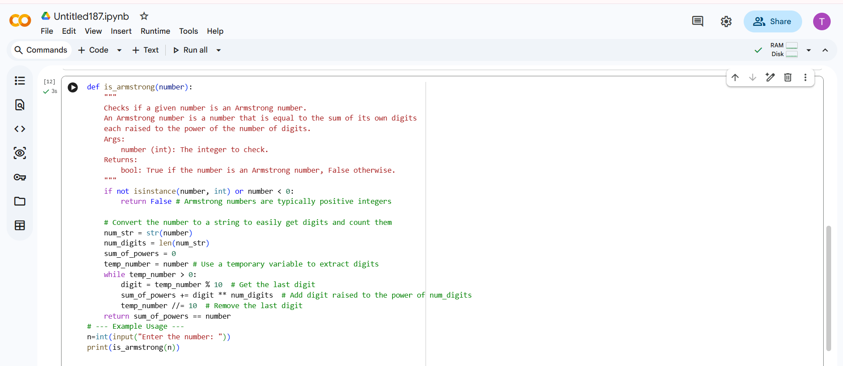

Output:
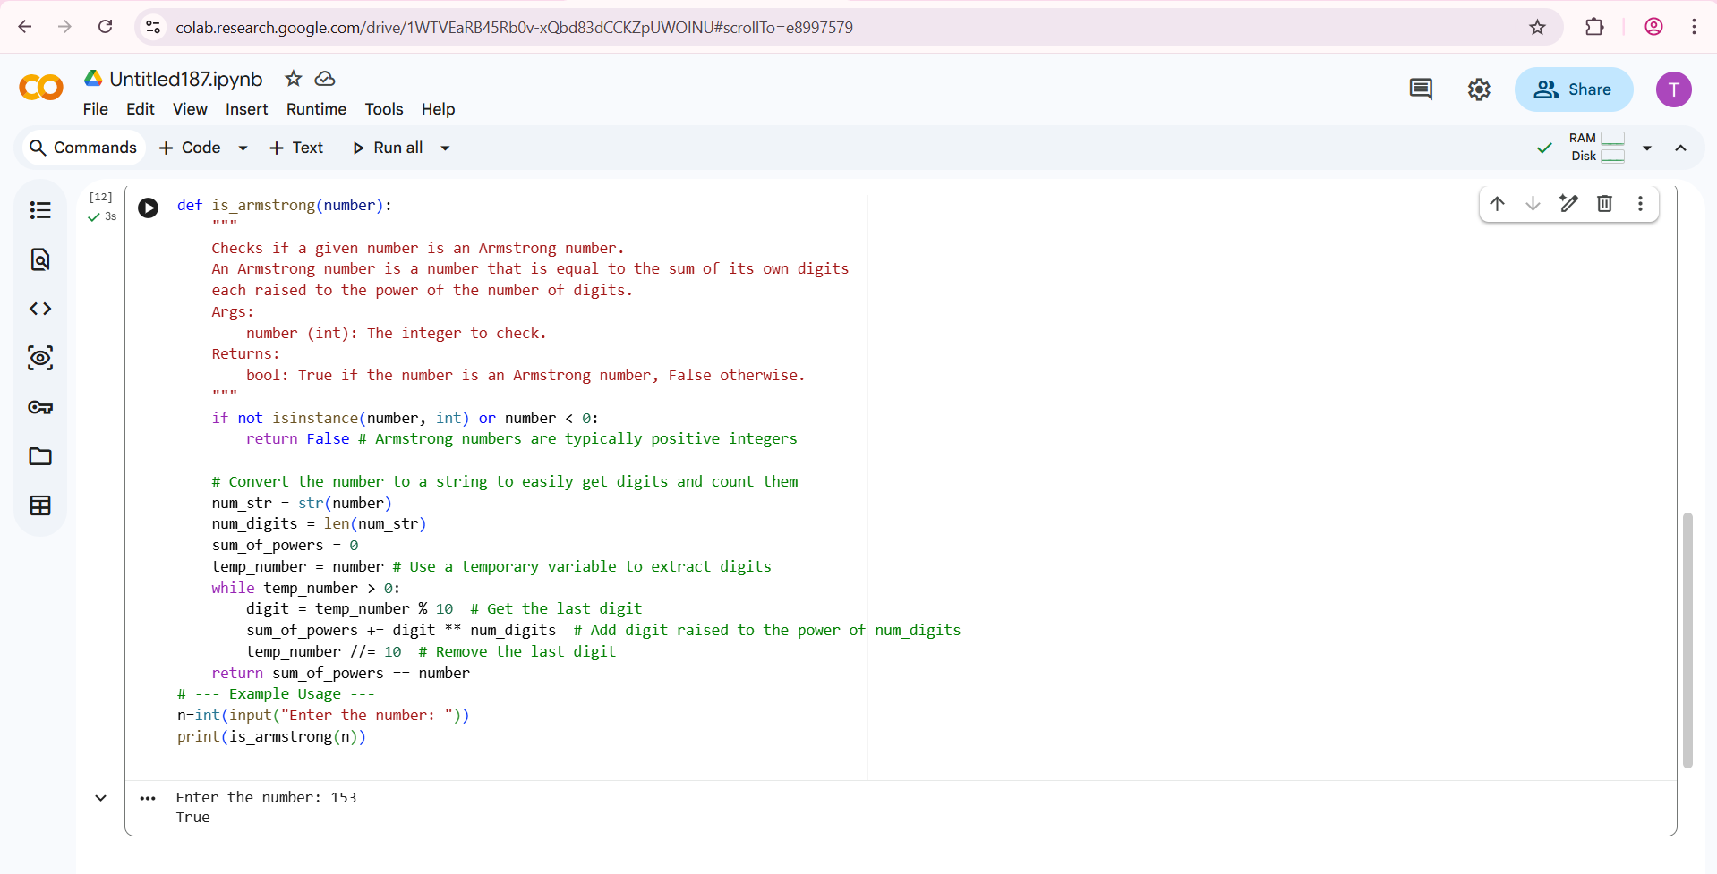

Prompt for GitHub Copilot:
# Python program to check Armstrong number

Screenshot:
Code:
def is_armstrong_number(num):
# Convert number to string to easily iterate over digits
str_num = str(num)
num_digits = len(str_num)
# Calculate the sum of the cubes of each digit
sum_of_cubes = sum(int(digit) ** num_digits for digit in str_num)
# Check if the sum of cubes is equal to the original number
return sum_of_cubes == num
# Input from user
number = int(input("Enter a number: "))
if is_armstrong_number(number):
print(f"{number} is an Armstrong number.")
else:
print(f"{number} is not an Armstrong number.")

Scenario:
Armstrong number logic is used to test numeric validation across AI tools.
Code Screenshot:
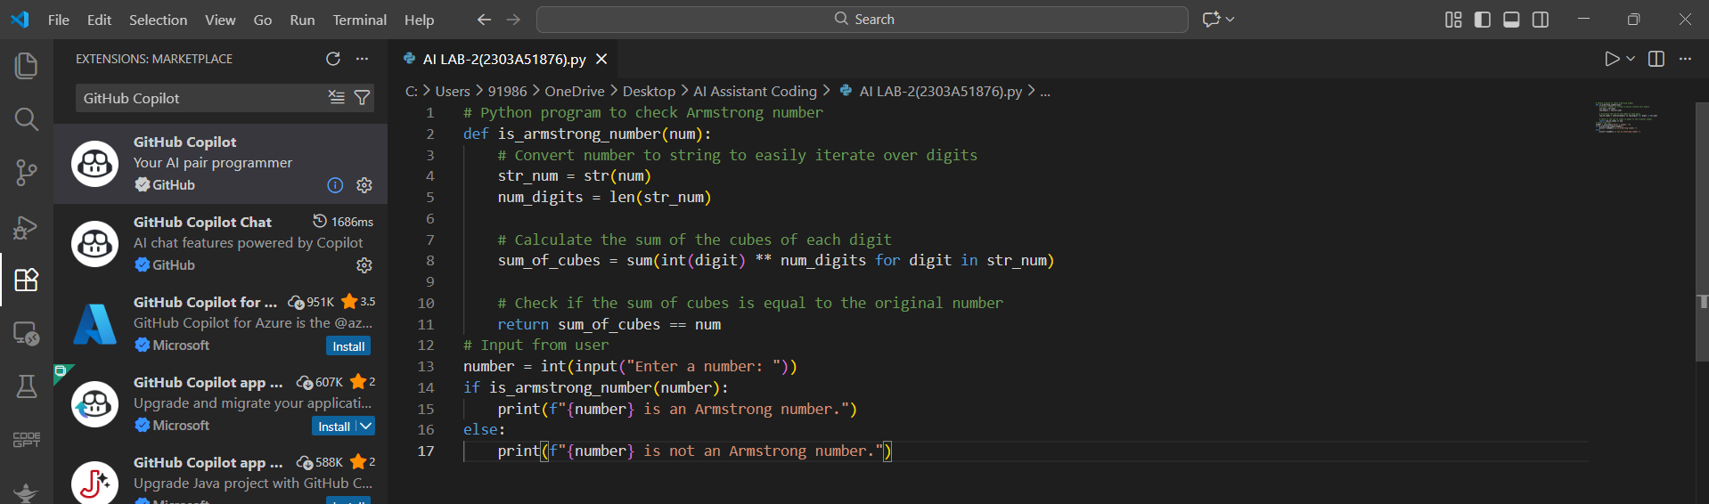
Output:
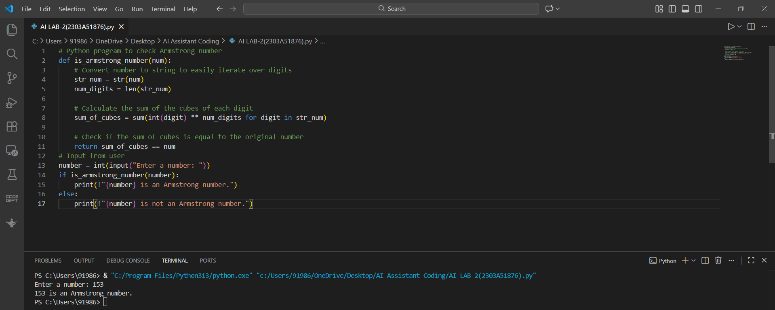
Comparison Table:
Feature | Google Gemini | GitHub Copilot
Code Accuracy | High | High
Explanation | Detailed | Minimal
Readability | Very clear | Concise
Beginner Friendly | Yes | Moderate
Explanation:
Both Google Gemini and GitHub Copilot successfully generate correct logic for checking an Armstrong number, but they differ in their approach and purpose.
- Google Gemini provides:
  - A complete Python program.
  - Step-by-step explanation of the logic involved.
  - Clear variable naming and comments.
  - Beginner-friendly reasoning that helps students understand why each step is used.
- GitHub Copilot focuses mainly on:
  - Fast code generation and auto-completion.
  - Minimal or no explanation of the logic.
  - Assisting experienced developers who already understand the concept.
  - Improving coding speed rather than conceptual learning.
Thus, while both tools produce correct results, Gemini emphasizes learning and clarity, whereas Copilot emphasizes productivity and speed.
Justification:
Using multiple AI tools allows developers to select tools based on learning or productivity needs.
By comparing multiple AI tools, developers and students can:
- Choose the right tool based on their learning or productivity requirements.
- Understand the strengths and limitations of each AI platform.
- Improve both conceptual understanding and coding efficiency.
Task-2
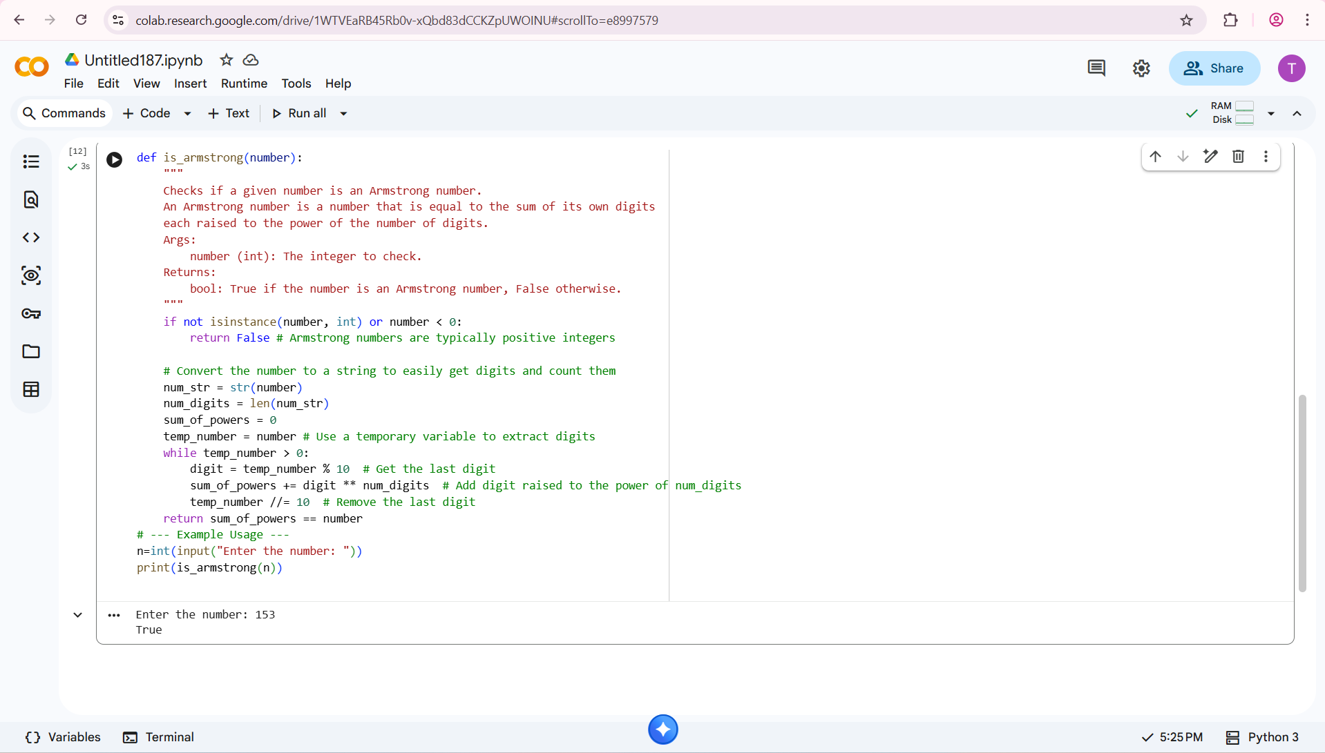

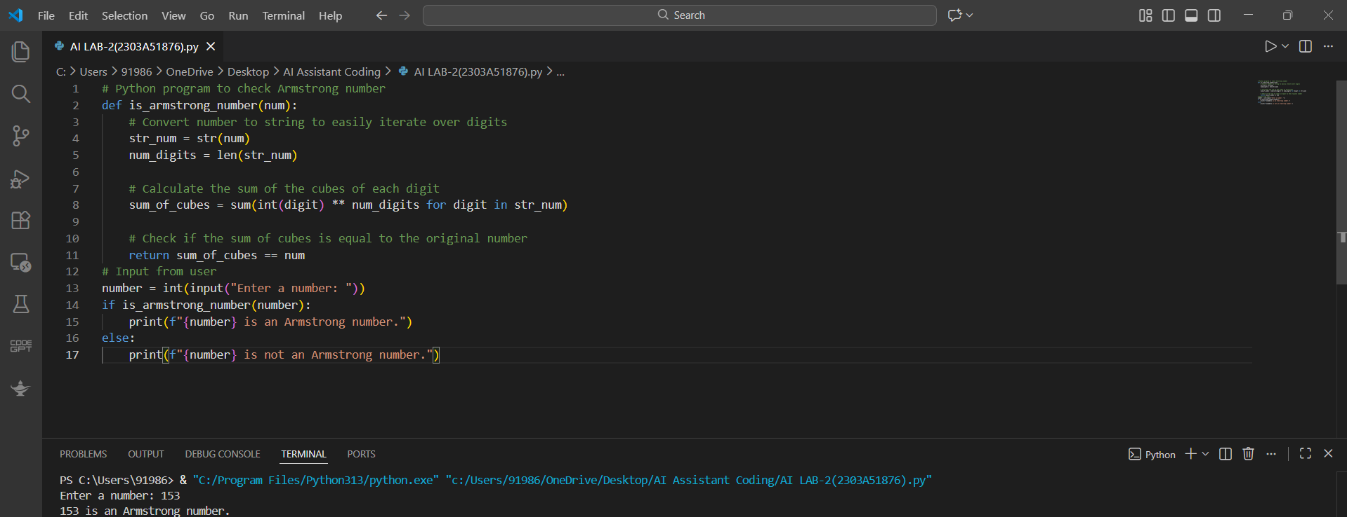

3Q) Task 3: Leap Year Validation Using Cursor AI
- Scenario:
You are validating a calendar module for a backend system.
- Task:
Use Cursor AI to generate a Python program that checks whether a given year is a leap year.
Use at least two different prompts and observe changes in code.
- Expected Output:
  - Two versions of code
  - Sample inputs/outputs
  - Brief comparison

Prompt 1 (Cursor AI):
#Write a Python program to check whether a given year is a leap year.
Screenshot:
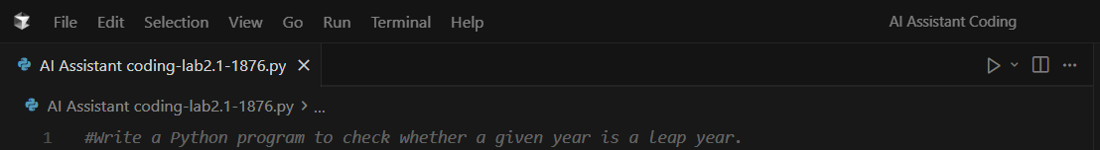
Code:
def is_leap_year(year: int) -> bool:
# Leap if divisible by 4, except centuries not divisible by 400
return (year % 4 == 0) and (year % 100 != 0 or year % 400 == 0)
year = int(input("Enter a year: "))
if is_leap_year(year):
print(f"{year} is a leap year.")
else:
print(f"{year} is not a leap year.")
Code Screenshot:
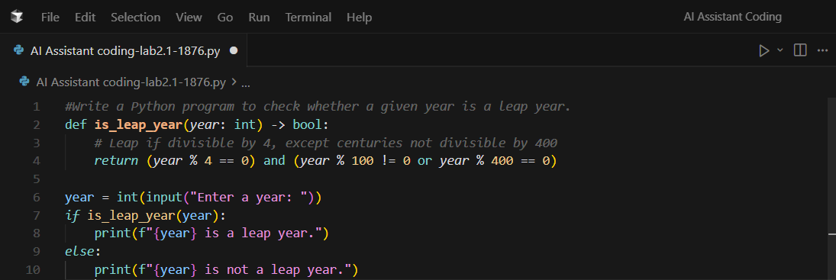
Output:
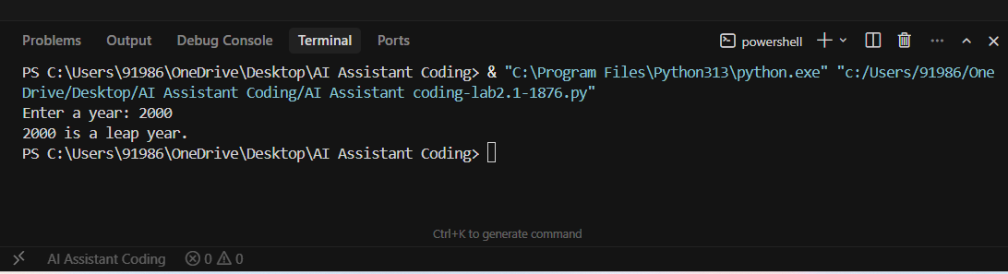
Prompt 2 (Cursor AI):
#Generate an optimized Python function to validate leap year using conditions.
Screenshot:
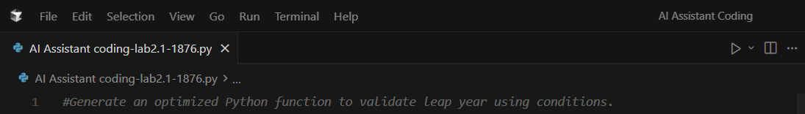

Code:
def is_leap(year):
return (year % 4 == 0 and year % 100 != 0) or (year % 400 == 0)
year = int(input("Enter year: "))
print("Leap Year" if is_leap(year) else "Not a Leap Year")
Code Screenshot:
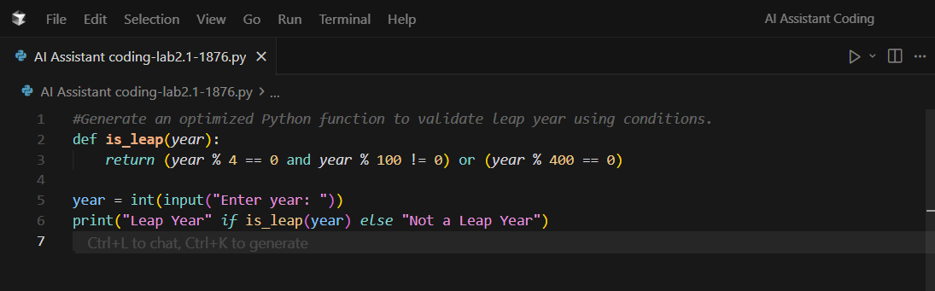
Output:
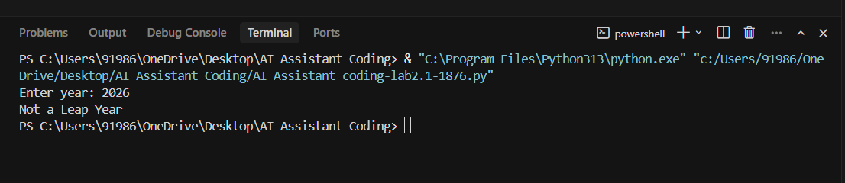
Scenario:
Leap year validation is required in calendar systems.
Explanation:
Leap year validation requires multiple conditions for accuracy.
The first prompt generates basic logic, while the second prompt improves structure and correctness.
Cursor AI adapts the code based on prompt detail, demonstrating prompt engineering effectiveness.

Justification:
This task highlights how AI improves code quality when prompts are refined.
Cursor AI supports refactoring and optimization, making it useful for professional development environments.
Task-3
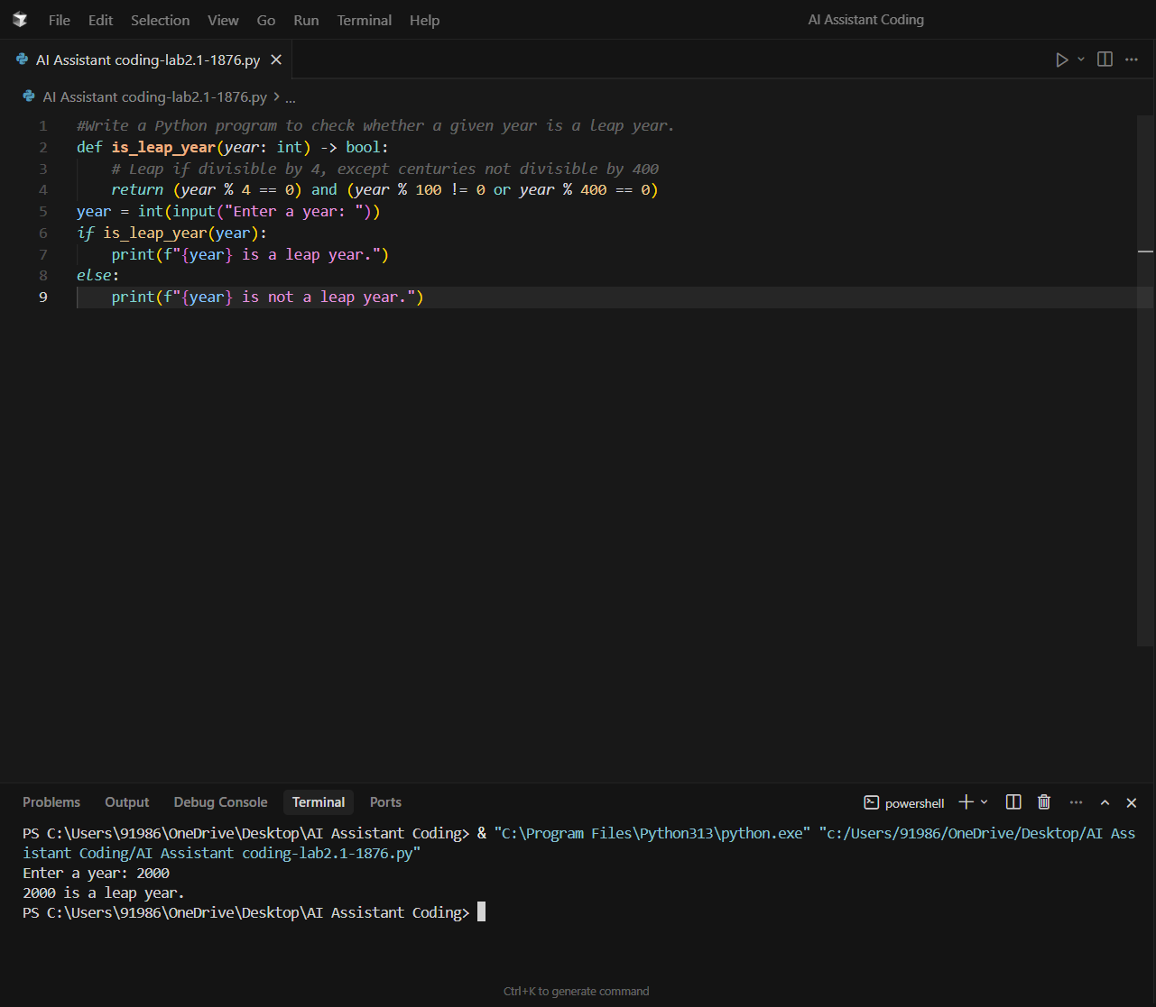
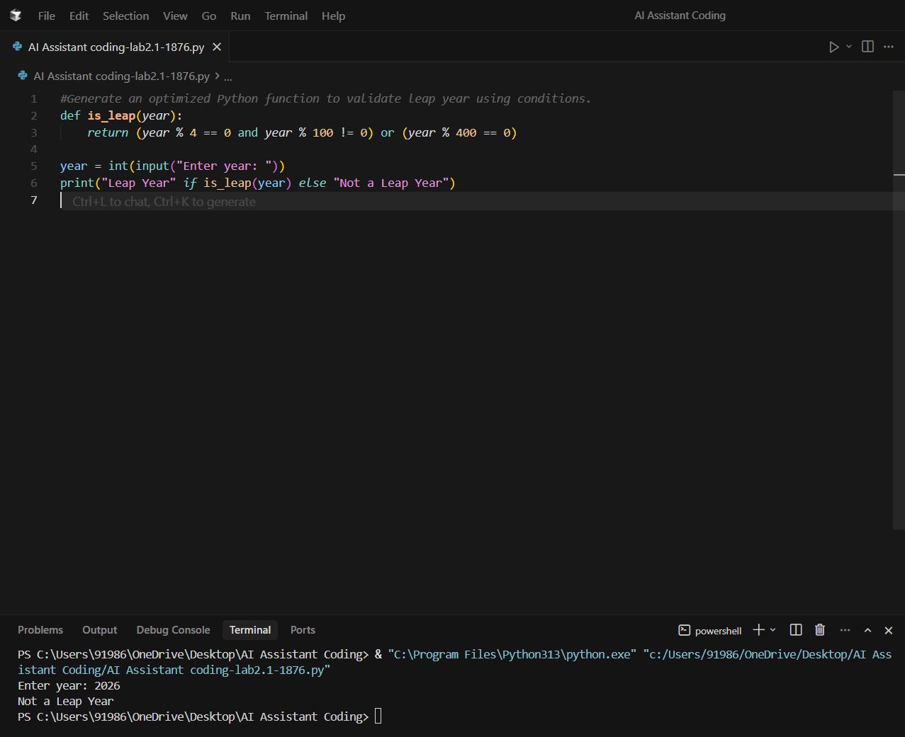
Task 4: Student Logic + AI Refactoring (Odd/Even Sum)
- Scenario:
Company policy requires developers to write logic before using AI.
- Task:
Write a Python program that calculates the sum of odd and even numbers in a tuple, then refactor it using any AI tool.
- Expected Output:
  - Original code
  - Refactored code
  - Explanation of improvements

Prompt 1 (For Student-Written Logic – Self Coding):
Problem:
Calculate the sum of odd and even numbers present in a tuple.
Screenshot:
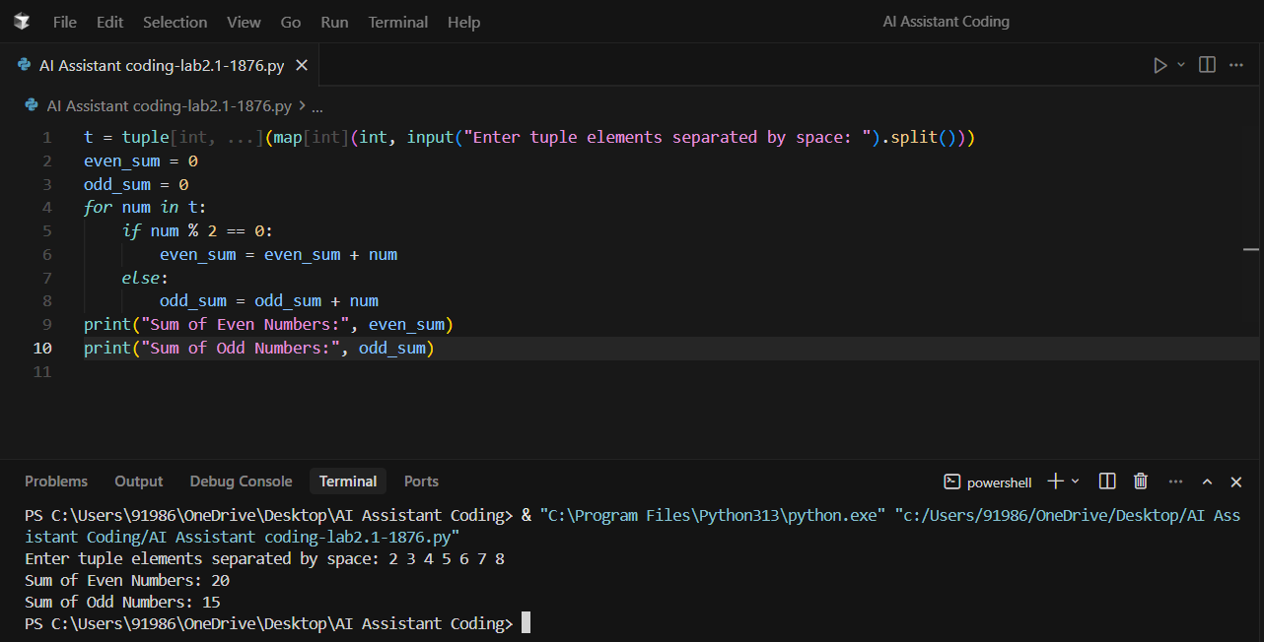
Code:
t = tuple(map(int, input("Enter tuple elements separated by space: ").split()))
even_sum = 0
odd_sum = 0
for num in t:
if num % 2 == 0:
even_sum = even_sum + num
else:
odd_sum = odd_sum + num
print("Sum of Even Numbers:", even_sum)
print("Sum of Odd Numbers:", odd_sum)
AI Refactoring Prompt:
#Refactor the Python code to improve readability and efficiency.
Screenshot:
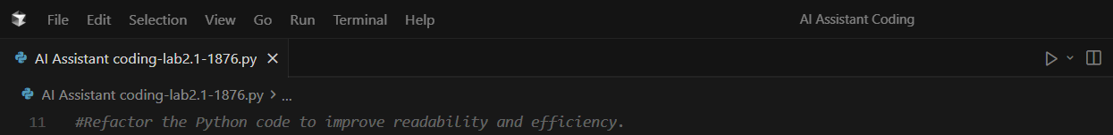
Code Screenshot:
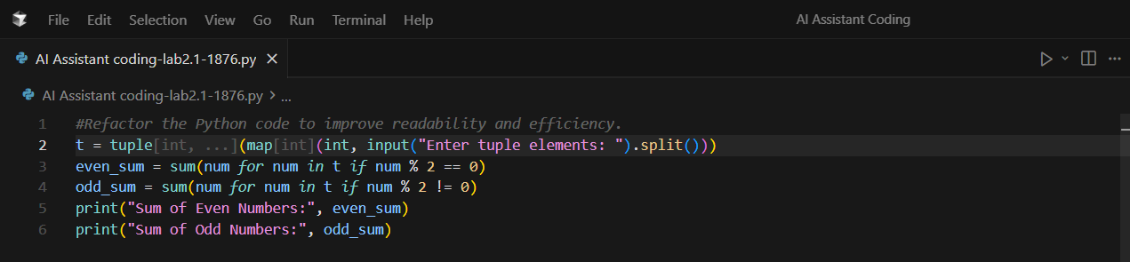
Output:
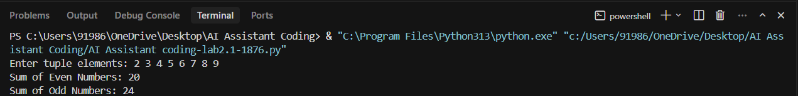
Refactored Code Prompt:
#Write a Python program to calculate the sum of even and odd numbers in a tuple(Refactored Code).
Screenshot:
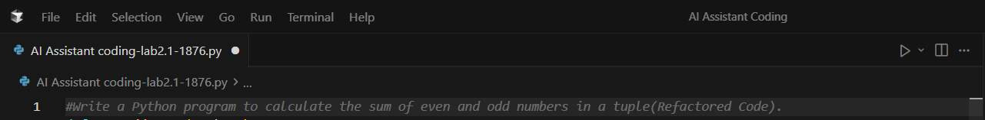
Code Screenshot:
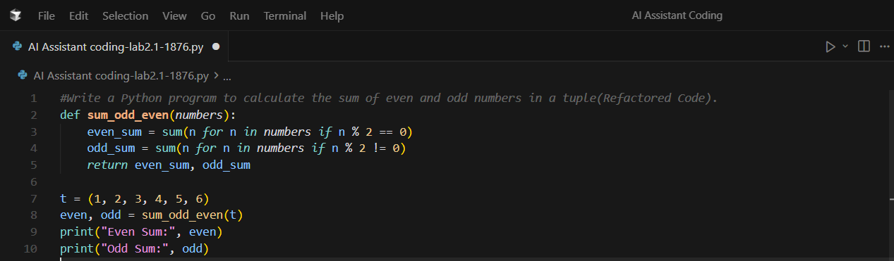
Output:
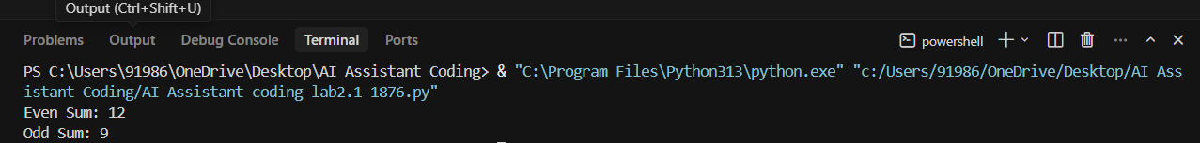
Scenario
Developers must write logic before AI refactoring.
Explanation:
The original code uses loops and conditional statements to separate odd and even values.
The AI-refactored code uses Python built-in functions and generator expressions.
This results in cleaner, more efficient, and reusable code without changing the logic.
Justification:
Writing logic manually ensures conceptual understanding.
AI refactoring improves code readability and performance.
This approach aligns with industry standards where AI assists but does not replace developer thinking.

